BISHOP WILTON PARISH COUNCIL

The Localism Act

The Relevant Authorities (Disclosable Pecuniary Interests) Regulations 2012

Notification by a Member of Disclosable Pecuniary and Non-Pecuniary Interests

I, (fu// name)

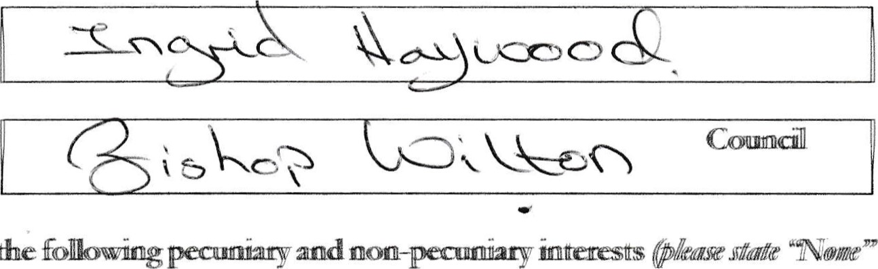

GIVE

NOTICE

that

have

the

a Member of (aulåpriD'))

rierte appropriate)):

PART A - PECUNIARY INTERESTS

NB — accoff&ce Section 34 of the ILGcahsm Act a connmitts an offence if, Tiiåout reasonable excuse, they fal to reistet pecurutty ntetests 28 days of talking office or fail to update their register wlthin 28 days of a change to their pecunlary interests.

'The following disclosable Pecuniary Interests of myself, my spouse or civil partner or any person Titth whom am living as husband or wife or any person with whom I am living as ifwe civil

(a) Any employment, office, trade, profession or vocation carried on for profit or gain.



(b)) Any payment or provision of any other financial benefit (other than from the authority) made or provided within the relevant period In respect of any expenses by me m caffylng out duties as a Member, or towards my elecdon expenses. This includes any payment or financial benefit from tmde within åe mening of Trade and Labour Relations Act 199)2



1. Any contract which is made between any of the above named persons (or a body in which any of the above peasom have beneficial interest\*) and the autho+y under wlhkll or services to be pnowaed or works to executed, which has bEenn fulllhy dhsclhurged„r

\* Body in which any of the above named persons has a beneficial interest means a firm in which any of the above named persons is partner or a body corporate of which any of the above persons is a director, or in the securities ofwhich any ofthe above manned persons has a beneficial interste

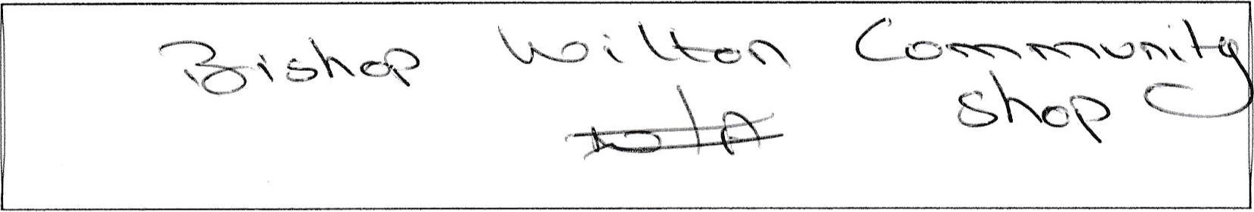

1. Any beneficial interest in land which is within the area of the %uthority-



1. Any licence (alone or jointly with others) to occupy land in the area of the authority for a month or longer-



1. Any tenancy where (to my knowledge) the landlord is the authority and the tenant is a body in which any of the above named persons have beneficial interest-



 Any beneficial interest in securities of a body where that body (to my knowledge) has a

place of business or land in the area of the authodty; and either the total nominal value of the securities exceeds Z25„OOO or one hundredth of the total issued share capital of that body; or if the share capital of that body is ofmore than one class, the nominal of the shares of any one class in which any of åe above named persons has a beneficial interest exceeds one hundredth of the total issued share capital of that class.

PART B - NON-PECUNIARY INTERESTS

NMI—Pecuniaxy of myself.. 

 Bodies to which I am appointed or nominated by the authority @ outside body appointments) other than bodies in which the authoHty has an interest.



1. Bodies exercrsrng functions of a public nature of which I am a Member (Including local enterprise partnerships, other councils, public health bodies, school governing bodies).

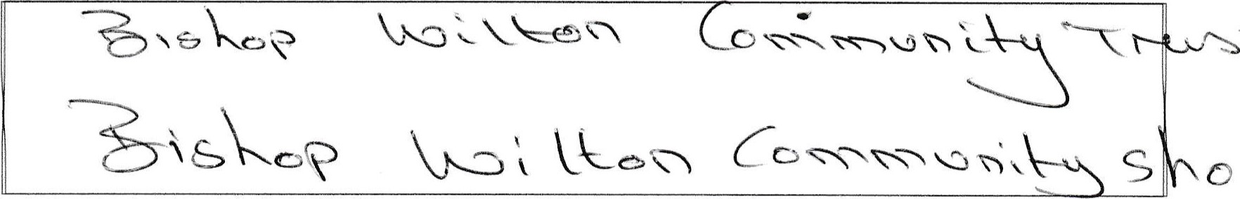

1. Bodies durected to cbantable purposes of which I am a Member (mclluång the Eons, the Masons, a Parochial Church Council; not just bodies registered with the Charity

Commission-

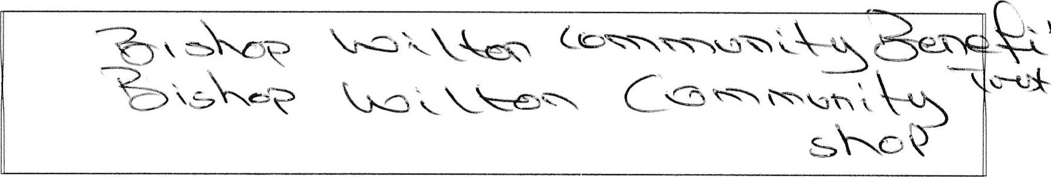

1. Bodies whose principal purposes Include influence of public opln.lon or policy (including any political party or Orade union) of which I am a Member-



1. Any voluntary work undertaken by me.

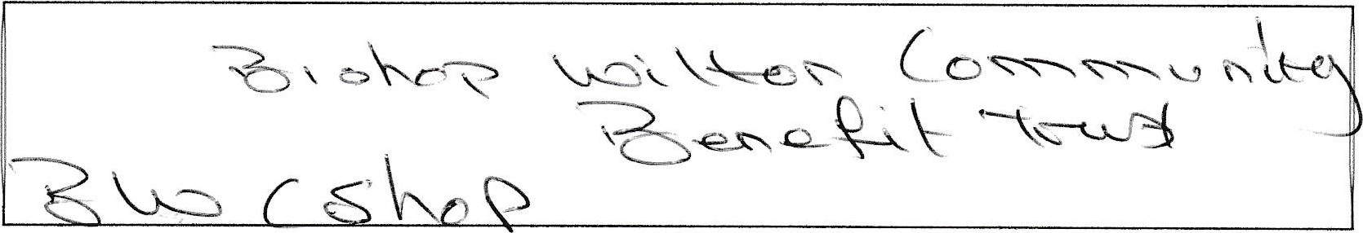

1. Any person from which I have received in my capacity as a Member a gift or hospitality tthalt almountts to the of least C25„



Date: Signed:

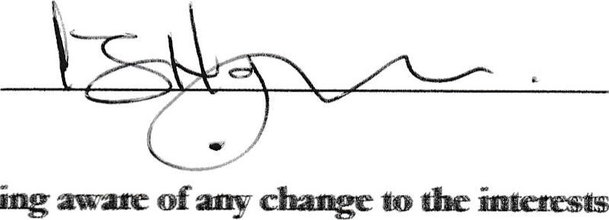NOTE: A member must within Z days oftrcoming aware to the interests specified above, provide written notificaü)n to the authority's monitoring offcer of that

INTERNAL - and reviewed by Ilkmocratuc Services

Name: Date: