Bishop Wilton Village Green
Biodiversity assessment and recommendations.
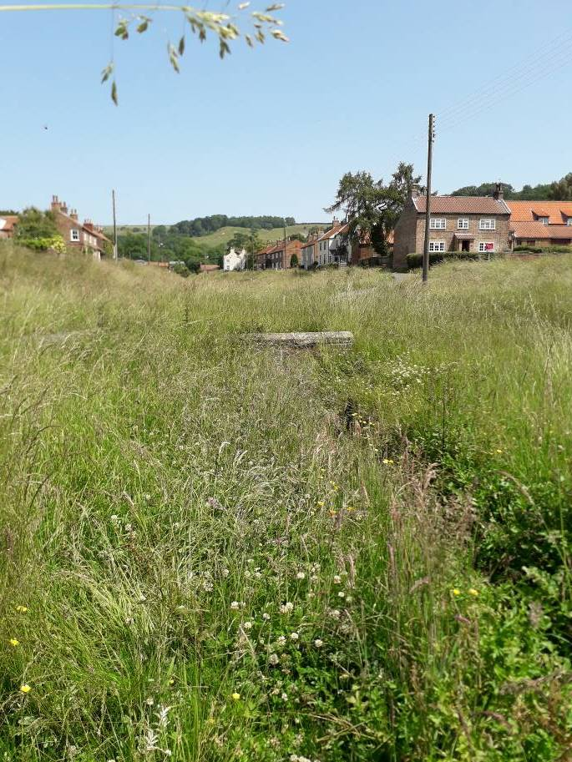

Context
Bishop Wilton Parish Council have taken a bold step in allowing the grass to grow on the village green. This approach has prompted some discussion, with concern that the uncut green could make the village look untidy.
The Parish Council has asked Terry Smithson to provide a view on the biodiversity value of the Village Green, and the merit of leaving areas uncut, and to make recommendations on future management.
A superficial ecological assessment was carried out on Saturday June 29th 2019, by Terry Smithson of Yorkshire Wildlife Trust. This comprised a standard walkover survey to record botanical species as well as incidental records of other species, and covered the area from the bus stop to the school.
At the time of the survey the grass had remained uncut for around 8 weeks and was in full growth. The survey was carried out on a hot, clear day with a light wind.

Biodiversity assessment
The botanical diversity of the site is typical of semi-improved grassland in the area, and the presence of some species indicate the permanence of the area as grassland.
The meadow is dominated by rather common species including false oat grass and common foxtail and there are some common herbs including creeping buttercup, white clover and hogweed. Some areas of the green support greater diversity and species of local value such as bulbous buttercup, meadow cranesbill, and meadow buttercup – species which have become increasingly uncommon as a result in changing farming practices and loss of traditional meadowland.
A number of insects were also recorded during the survey including red tailed bumblebee, meadow brown butterfly and common skipper. These species were feeding on the wildflowers and several species breed on grasses.
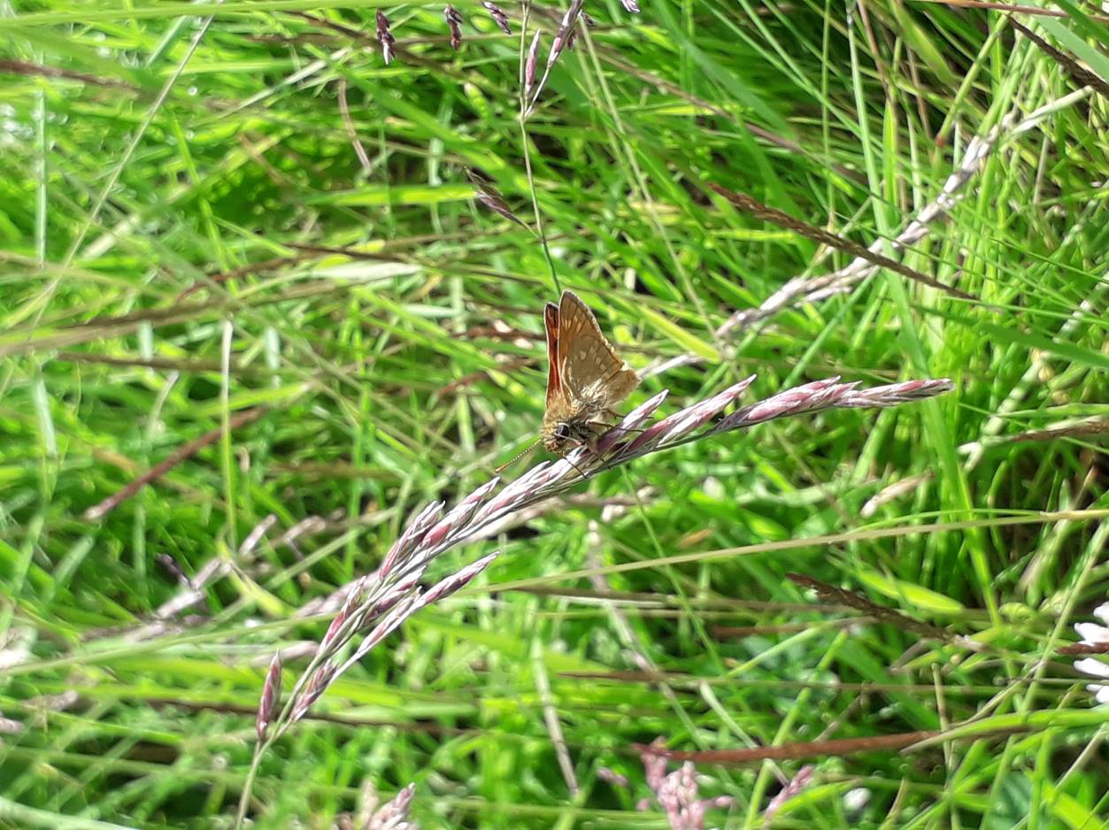
Large skipper – Rowan Smithson.
The beck itself supported a higher diversity of plants, including water figwort and water speedwell, as well as a good diversity of aquatic insects including caddis fly larvae and water boatman.
The village green supports a diversity of plant species including some species which are becoming increasingly uncommon in the countryside. The abundance of insect life in the meadow and in the beck was impressive for such a small area. It is clear that this abundance of life is a result of not cutting the meadow and allowing the wildflowers and grasses to grow.
Bishop Wilton supports a good population of toads and great crested newts which breed in ponds within and on the outskirts of the village. Outside of the breeding season these amphibians require grasslands, scrub and woodland to find food.
Bishop Wilton Beck was of note in supporting a population of water voles, unfortunately this endangered mammal has not been seen for a number of years and it is likely that it has been lost, as a result of overzealous vegetation management along the beckside.

The value of creating a meadow on the village green

Wildlife
Some facts:
- The UK has lost 97% of its wildflower meadows since the Second World War.
- 40% of insect species are in decline (German study found 75% reduction in insect biomass).
- The number of widespread butterflies fell by 58% on farmed land between 2000 and 2009.
- The UK swift population has declined by 38% in the last 25 years.
- The water vole is the UKs most rapidly declining mammal and has disappeared from 94% of its former haunts.
We are in a biodiversity crisis. Humans have wiped out 60% of animal populations since 1970 and this this loss of biodiversity, the stuff of life, also puts our health and livelihoods at risk.
Habitat loss and degradation is the single biggest cause of biodiversity loss. As we take away the places where wildlife lives, and create an increasingly monotone environment, the abundance and diversity of life declines. The most effective way to restore biodiversity therefore, is to create new areas.

Wellbeing
There is now abundant and compelling evidence which illustrates the value of wildlife rich greenspace in promoting good physical and mental health. At a time when we are facing a health crisis in obesity and diabetes and growing rates of low wellbeing and mental ill health nature based interventions are being seriously considered as a preventative service, an early intervention, and treatment option – all in one service.
We are lucky to live in such a green environment, but it is the colours, sounds, and smells – created through a rich biodiversity, which really stimulates the senses and enriches our being.
Surely a walk through a flowering meadow offers greater joy to more people than a lawn.
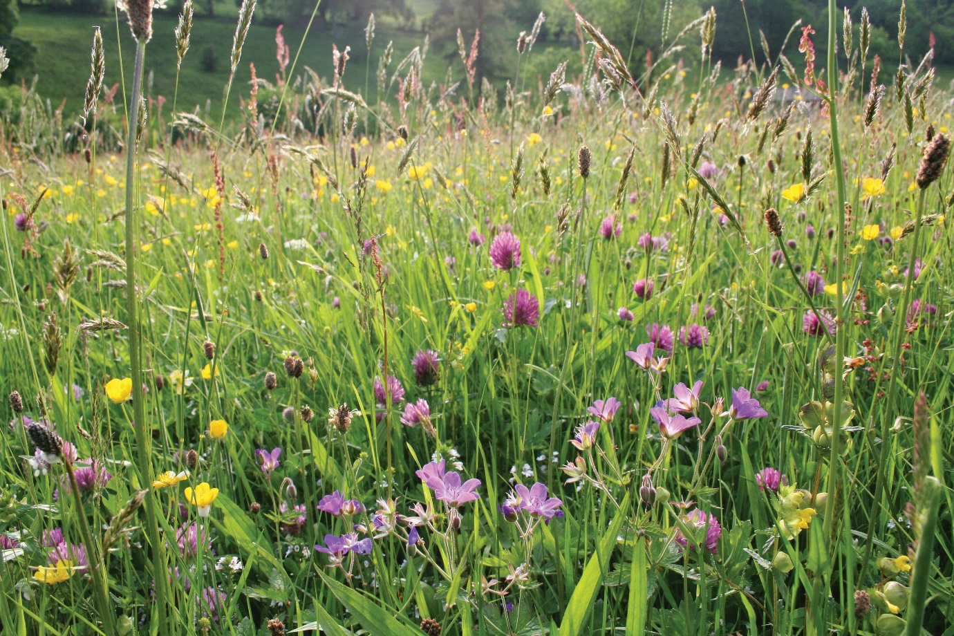
Meadow – Trevor Dines.

Climate chaos and local finance
We are also facing climate chaos as a result of human emissions of carbon dioxide into the atmosphere. The UK Government has recently announced a Climate Emergency and has set targets to reduce carbon emissions.
Allowing the grass to grow during the summer will reduce the number of cuts from three to one and so reduce carbon emissions and the financial cost to the Parish.

Recommendations for future management
Action is needed at all levels to address this biodiversity crisis. UK government have set out targets for halting the loss of biodiversity; A Green future: our 25year plan to improve the environment seeks the creation of wildflower meadows across the UK. East Riding of Yorkshire Biodiversity Action plan sets out targets to create more wildflower grasslands in the county. Some Parish Councils in Yorkshire have developed their own Parish Plan and are taking action to bring wildlife back.

The Meadow
Traditional management for meadows would see the field ‘shut up’ from May through June or July to allow the grass to grow before cutting for hay and winter fodder. The fields would likely then be grazed from late summer through the autumn, and depending on the area and livestock, perhaps grazed early in the year to take a spring bite.
On the village green it would be sensible to follow a similar approach and to allow the growth from late April or May through to mid-July to allow seed set. Grass cuttings should then be removed. This could be sold as haylage to offset the cost of mowing.
Steps should be taken to increase the botanical diversity of the meadow by introducing seed from more wildlife rich areas. The Poorlands could provide a valuable donor site either by collecting seed by hand or by strewing hay when taken (a popular community activity).

The Beck
Retention of the long vegetation along some lengths of the beck would add value by reducing run off and siltation into the beck (reducing pollution of the water course), slowing the flow of water into and along the beck (reducing flood risk further downstream, and by increasing its biodiversity value. It is important to note that some cutting of the beckside vegetation will be needed to prevent overgrowing or tree establishment.
A simple way of achieving this would be to alternate the cutting of the beckside vegetation through the year. The beck vegetation could be divided into 6 sections – left and right banks for each section of the village green (bus stop to cross road, cross road to steps, steps to school). Staggered sections would be cut along with the meadow (mid-July), with the remaining areas receiving a cut once the July cut areas have grown up (probably in October). In this way the beck would have long vegetation along its entire length, but the season’s growth of vegetation would be removed each year.
Terry Smithson, July 9th 2019

Appendix – list of species recorded from the village green in June 2019. For ease, only common names are given. Those species of particular note are in bold.
Area 1 – from bus stop to cross road
False oat grass | Perennial rye grass | Dandelion
Common foxtail grass | Red fescue | Creeping buttercup
Cock’s foot grass | Glaucous sedge | Bulbous buttercup
Annual meadow grass | Broad leaved dock | Silverweed
Rough meadow grass | Ribwort plantain | White clover
Smooth meadow grass | Common nettle | Red clover
Area 2 – from cross road to steps
False oat grass | Hard rush | Dandelion
Common foxtail grass | Goat’s beard | Creeping buttercup
Cock’s foot grass | Hedge bindweed | Bulbous buttercup
Annual meadow grass | Hogweed | Silverweed
Rough meadow grass | Broad leaved willowherb | White clover
Perennial rye grass | Herb robert | Broad leaved dock
Red fescue | Meadow cranesbill | Ribwort plantain
Yorkshire fog | Hoary willowherb | Common nettle
 |  | Creeping cinquefoil
Area 3 – steps to school
False oat grass | Yorkshire fog | Dandelion
Common foxtail grass | Timothy grass | Creeping Buttercup
Cock’s foot grass | Meadow buttercup | Silverweed
Annual meadow grass | Butterbur | White clover
Rough meadow grass | Curled dock | Broad leaved dock
Smooth meadow grass | Meadow cranesbill | Ribwort plantain
Perennial rye grass | Goat’s beard | Common nettle
Red fescue | Hogweed | Creeping cinquefoil
 | Orange hawkweed
The Beck
Fools parsley | Water figwort | Meadowsweet
Water speedwell | Meadow buttercup
Other Species – whole area
Ringlet butterfly | Common froghopper | Water shrimp
Small tortoiseshell butterfly | Black garden ant | Caddis fly larvae
Common skipper butterfly | 7 spot ladybird
Common blue butterfly | Red tailed bumblebee
Meadow brown butterfly

