Full Sutton Industrial Estate. A Review of its Impact on Surrounding Villages

The size and range of commercial enterprises and their associated activities on Full Sutton Industrial Estate have steadily grown since the land they now occupy was purchased in a disposal sale from the Ministry of Defence in 1966. The estate has undoubtedly added to the economic health and employment opportunities within the county, but indisputably, this has come at a cost to local residents of villages adjoining, and close to the estate.
The Parish Councils of Bishop Wilton and Full Sutton and Skirpenbeck made a request to ERYC in February 2017 to carry out a review of the impact of the Industrial Estate at Full Sutton on the adjacent parishes. A Scoping Document of nine specific areas of concern was provided by the PCs as a framework on which to construct and execute the Review.
For guidance, three Expected Outputs from investigation of each the nine areas for concern, were provided in the Scoping Document:
- The identification and characterisation (both qualitatively and quantitatively) of both the causal effects (impacts) and adverse activities
- Proposed measures to mitigate and where possible, eliminate adverse impacts
- Proposed measures to ensure adverse impacts do not worsen (e.g. by granting planning permission for expansion of certain activities adversely impacting neighbouring parishes)
One of the primary concerns of the Parish Councils was associated with the speed, length, weight and frequency of vehicles (both commercial and privately-owned) entering and leaving the Industrial Estate. A survey was carried out by ERYC, but sadly it failed to address all of these important parameters. Without prior consultation with the PCs as to the most appropriate monitoring locations, equipment was set up on Moor Lane, Full Sutton and The Balk, Youlthorpe. Monitoring equipment recorded the following parameters: i) total number of vehicles per day and week, ii) mean speed, iii) HGVs per day and iv) the number of vehicles exceeding the police’s benchmark for enforcement (35mph for Moor Lane and 68mph for The Balk). Regrettably, the maximum speed of vehicles on these two roads was not monitored despite speed being of major concern to local residents! The following statement was made by ERYC after the survey, ‘… the situation is not sufficient enough to warrant engineering measures or movement orders and further studies or analysis is unlikely to change that decision. For these reasons we are unable to support any further investigations into the speeding issues surrounding HGVs.’
Concern was expressed by the PCs about the dangerous volume and frequency of auto-related debris being jettisoned onto roads around the Industrial Estate (see illustrations). ERYC did not monitor this, but contact auto companies on the Industrial Estate to remind them of their duty of care and highway safety. Other than this, ERYC considered that no further action was necessary. The PCs did request that because of the obvious dangers to road-users and pedestrians, the Council’s Public Protection Office become involved with this issue, but the Council declined to respond to the request.
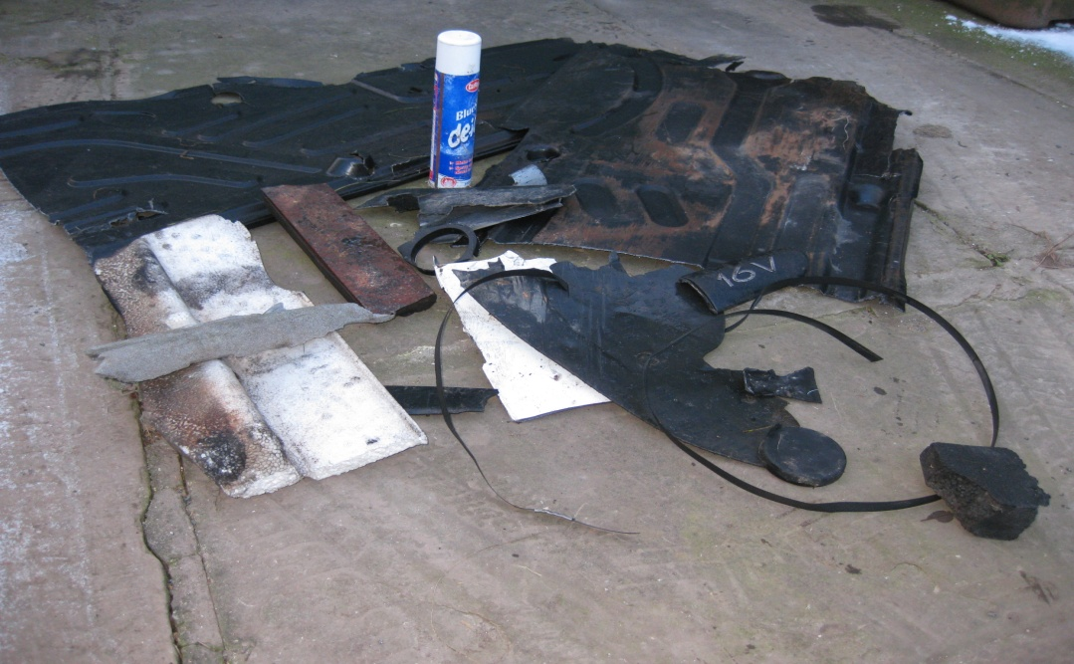

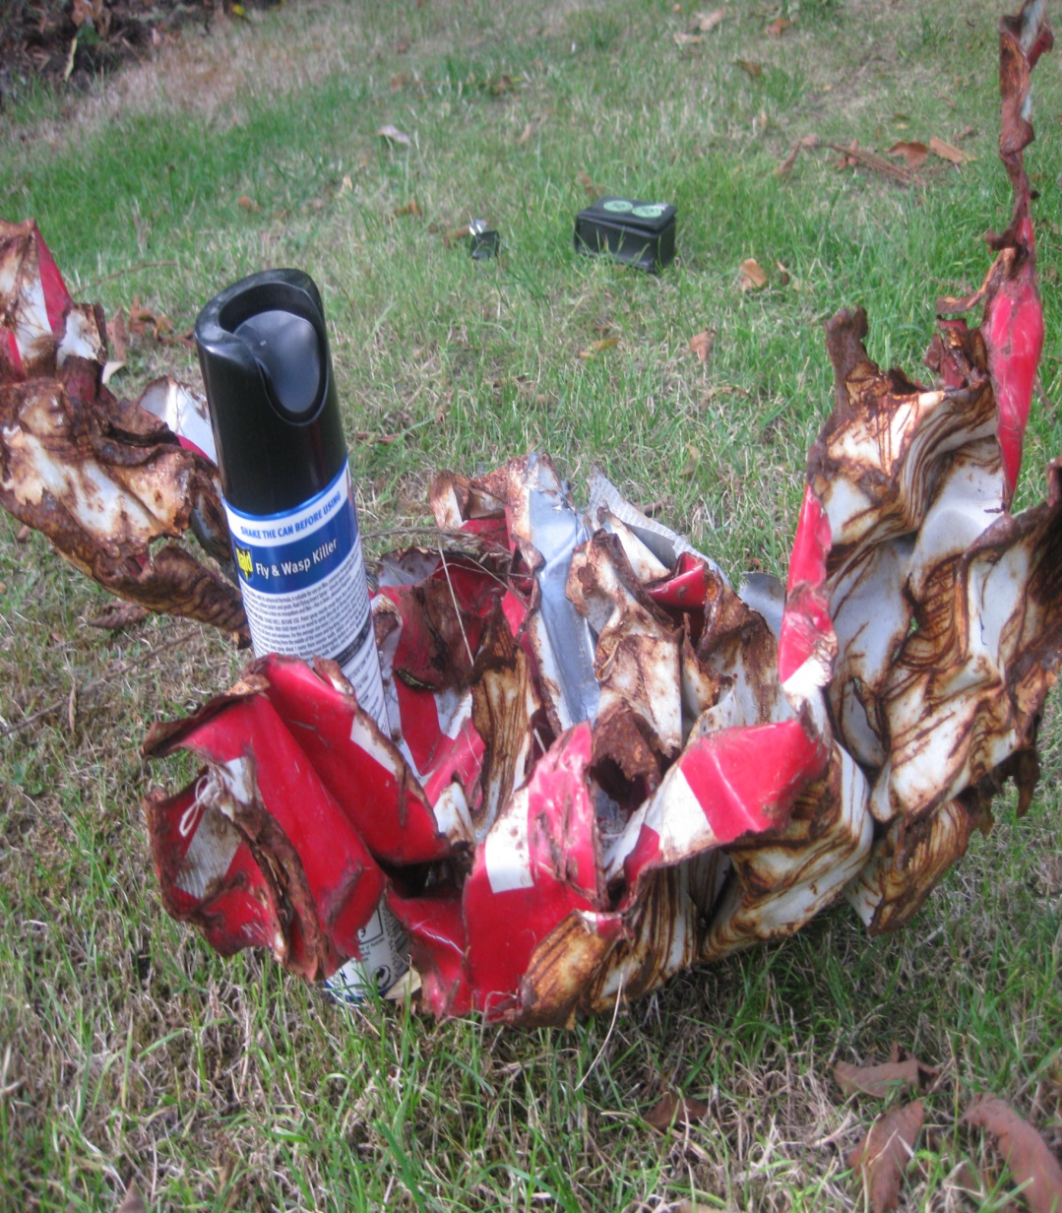

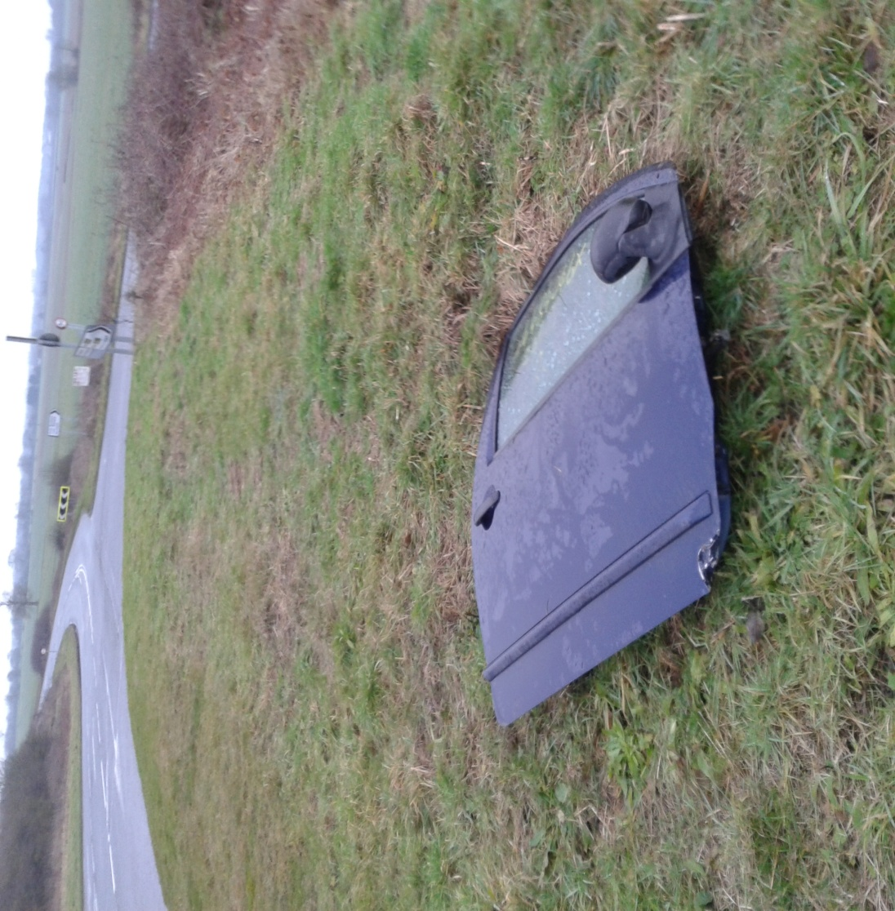

Auto-related Debris Found on Hatkill Lane near Full Sutton Industrial Estate
The Community Policing Team were asked whether they were ‘aware of the ongoing issue’ and life-threatening potential of large, heavy pieces of debris being thrown at speed into the path of cars, cyclists and pedestrians in neighbouring parishes. No response was received.
The PCs have been concerned at the amount of litter and small items of debris arising from the Industrial Estate, particularly drink cans and non-biodegradable catering containers. The Council’s Head of Streetscene Services was asked in June 2017 by Director of Planning and Economic Regeneration what had been formally reported from the Full Sutton area with respect to small items of debris arising from the Industrial Estate, and also to assess and comment on the general situation in the surrounding highways. We are unsure whether this has been done, but certainly, no report has been forthcoming and no recommendations made.
The Streetscene Enforcement Officer in conjunction with the DVSA (Driver and Vehicle Standards Agency), did carry out a spontaneous ‘stop and check’ on a road within Full Sutton Industrial Estate to establish the roadworthiness and environmental compliance of vehicles visiting the estate. Frighteningly, all of the X7 randomly-stopped vehicles had defects of some kind, serious enough to warrant prohibition orders. Despite the high proportion of vehicles being defective, no further action has been taken by the authorities to monitor this demonstrably serious problem.

The PCs also asked where geographically in the parishes the major adverse impacts were being felt most who was being adversely affected, when during the day the impact was most felt and how the adverse impacts were being generated. Again, none of these were addressed by ERYC.
Regrettably - and to our surprise - ERYC could not agree that there were any significant adverse impacts or areas of concern arising from activities on the Industrial Estate (with the possible exception of the roadworthiness of some vehicles), and accordingly, none of the three Expected Outputs outlined above were delivered by the Council.
The results and Outputs of the Review could have be very valuable for - and feed directly into - any future Community or Parish-led Development Plan which the PCs may wish to have undertaken. Such a Development Plan might for example, include proposed policies covering, housing, retail, industry, heritage and landscape.
Regrettably, as no Outputs were forthcoming from ERYC, this potentially important contribution will not be possible.

