BISHOP WILTON PARISH COUNCIL
The Localism Act 2011
The Relevant Authorities (Disclosable Pecuniary Interests) Regulations 2012

Notification by a Member of Disclosable Pecuniary and Non-Pecuniary Interests
I, (fid/ name)
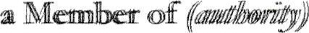 | Council
GIVE NONCE that have the following pecuniary and non-pecumary interests .Mcz//ce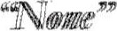
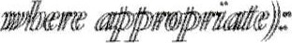
PART A - PECUNIARY INTERESTS
NB - accot&ce vitth Section 34 of the Localism Act 2011, person cam-Tmiitts offence if, viiåcouut treasonable excuse, they fall to register theiir pecunintty interests Within 28 days of talki% office or fail to update their register within 28 days of a change to their pecunrary interests.
The following disclosable Pecuniary Interests of myself, my spouse or civil partner or any person With Thom am living as husband or wife or any person with whom I am living as ifwe vete civill
(a) Any employment, office, trade, profession or vocation carried on for profit or gain.
Any payment or provision of any other financial benefit (other than from the authority)) made or provided within the relevant penod In respect of any expenses incurred by me in carrying out duÅes as a Member, or towards my expenses. This includes any
"Jid Labour Relations (Camsoli&tion) Act
- Any contract which is made between any of the above named persons (Of a body in which 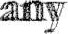ofthe above named persons have a interest#) and the authority under or services are fro be prowi&d or works aure to 1k executed, aod which Ins been fumy disclhrxrged-
* Body in which any of the above named persons has a beneficial interest means a firm in which any of the above named persons is partner or a body corporate of which any of the above named persons is a director, or the securities ofwhich any ofthe above persons has a beneficial interest-
- Any beneficial interest in Ind which is within the area of the •authority-
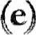 Any licence (alone or jointly with others) to occupy land in the area of the authority for a month or
(f) Any tenancy where (to my knowledge) the landlord is the authority and the tenant is a body in which any of the above named persons have a beneficial interot-

BOC VAL
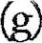 Any beneficial interest In of a body where that body (to my knowledge) has a
place of business or land in the area of the authority; and either the total nominal valæ of the securities exceeds or one hundredth of the total issued share capital of that body; or ifthe share capital of that body is ofmote than one the total nominal valhue of the of any one class in which any of the above named persons has a beneEdal interest exceeds one hundredth of the total issued share capital of that class.

PART B - NON-PECUNIARY INTERESTS
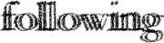Non-Pecumiaty ofmyseÆ
- Bodies to which I am appointed or nominated by the authority @ outside body appointments) other than bodies in which the authority has an interest.
- Bodies exercising functions of a public nature of which I am a Member (Including local enterprise partnerships, other councils, public health bodies, school governing bodies).
ßiShcp  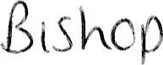 | Schccl 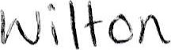 SCIACCA | bccly
- Bodies directed to chantable purposes ofThiich am a Member (including the Lions, the Masons, a Parochial Church Council; not just bodies registered with the Charity
8csRcp 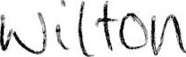 | Vdllacy(
- Bodies whose principal purposes Include Influence of public opinion or policy @cluding any political party or trade union) of which I am a Member-
- Any voluntary work undertaken by me.
DDPC\CR\Democmtic\localism_act_2011-docx
- Any person from which I have received in my capacity as a Member a gift or hospitality that to the vallur of Zit least
Date: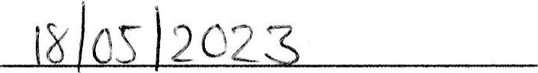 Signed:
NOTE: A member mustwithin days ofbecoming aware ofany to intetests specified above, provide written notificaü)n to the authority's monitoring offcer of that

INTERNAL - tecaved and by Democratuc SetVTces
Name: Date:
DDPC\CR\Democratic\localism_act_2()1 Ldocx

