BISHOP WILTON PARISH COUNCIL
The Locaüsm Act
The Relevant Authoriües (Disclosable Pecuniary Interests) Regulations 2012

Notification by a Member of Disclosable Pecuniary and Non-Pecuniary Interests
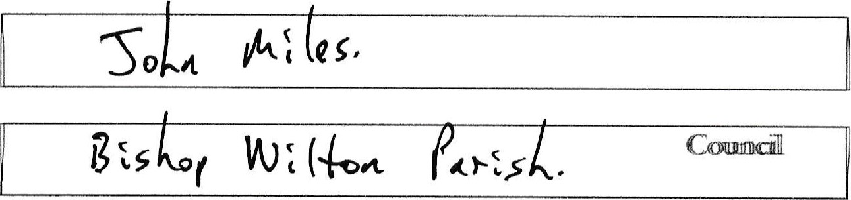
I,
(fid/
name)
a
Member
of
(@uåxpriily))
GNE N(YIICE that 1 have the fol%wing pecuniary and non-pecunnty interests (Please D']erte appropriate)):
PART A - PECUNIARY INTERESTS
NB - In accordance With Section 34 of the Localhlsm Act 2011, a person committs offence if, viåout treasonable excæe, they fail to register tthehtr pecunntty interests 28 (Lys of fralkiing office or to update their register within 28 days of a change to their pecuniary Interests.
The following disclosable Pecuniary Interests of myself, my spouse or civil partner or any person vitth whom am living as husband or wife Of any person with whom I am living as ifwe vete civil
(a) Any employment, office, trade, profession or vocation carried on for profit or gain.
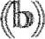 Any payment or of any other financial benefit (other than from the authority) made or provided within the relevant peHod in respect of any expenses ancured by me in carrying out duHes as a Member, Of towards my elecåon expenses. This includes any paymamt or financEl benefit from a trade svi±in üe mea.ming of the Tade Umiorn and Labour
Ldocx
- Any contract which is made between any of the above named persons (or a body in which any of the above persons have a beneficial interest' and the authority under or services fro pnowaed or works are to executed, and bas mot been fulT}y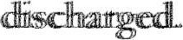
* Body in which any of the above named persons has a beneficial interest means a firm in which any of the above named persons is a partner or a body corporate of which any of the above nanned persons is a director, or in the securities ofwhich any ofthe above named persons has a beneficial interest..
- Any beneficial interest in lu.nd which is within the area of the tufhority-

Ito
Any licence (alone or jointly with others) to occupy land in the area of the authority for a month or
(f) Any tenancy where (to my knowledge) the landlord is the authority and the tenant is a body in Which any of the above named persons have a beneficial interest-
Any beneficial interest in securities of a body where that body (to my knowledge) has a
place of business or land in the area of the authority; and either the total nominal value of the securities exceeds L25,OOO or one hundredth of the total issued share capital of that body; or if the share capital of that body is ofmore than one class, the total of the shares of any one class in which any of the above named persons has a benefcil Interest exceeds one hundredth of the total issued share capital of that class.
Ito Lg.."
I.docx

PART B - NON-PECUNIARY INTERESTS
TIE intterestts of myseÆ
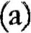 Bodies to which I am appotnted or nominated by the authority @ outside body appointments) other than bodies in which the authoHty has an interest-
- Bodles exercising functions of a public nature of which I am a Member (Including local enterprise partnerships, other councils, public health bodies, school governing bodies)-
- Bodies directed to chantabUe purposes ofwhich I am a Member (includmg the Lions, the Masons, a Parochial Church Council; not just bodies registered with the Charity Commission-
- Bodies whose prlnclpal purposes Include Influence of public opinion or policy (Including any party or trade union) of which I am a Member-
- Any voluntary work undertaken by me.
- Any person from which I have received in my capacity as a Member a gift or hospitality that amounts to the of at least C23
Date: Signed: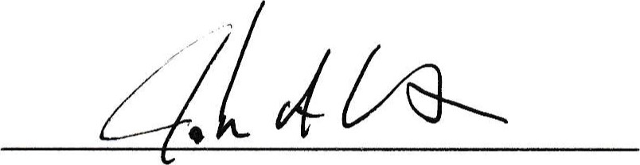

NOTE: A member mustwithin28 days ofbecoming awar ofany to the specified above, provide written notification to the authority's monitoring omcer of that

INTERNAL - received and rtevrved by Saviices
Name: Date:

