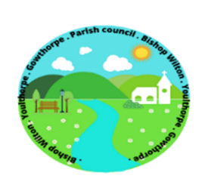

Parish Council of Bishop Wilton
The Annual Meeting of Bishop Wilton Parish Council, will be held on
Thursday 18th May 2023 at 6.30pm in Bishop Wilton Village Hall.
THIS IS AN OPEN MEETING AND MEMBERS OF THE PRESS AND PUBLIC ARE WELCOME TO ATTEND.
The items to be discussed and agreed are detailed below.
Parish Council Agenda items
- To receive Apologies.
- To receive nominations and agree election of Chair
- To receive Chair’s declaration of acceptance of office
- To receive members declaration of acceptance of office
- To receive nominations and agree election of a vice chair
- To receive Chair’s report for 2022/2023
- Approval and review of delegation of sub committees and appointment of officers – Personnel, Playground, Flyers and advertising, Gritting, Village Green Maintenance
- To agree councillors areas of responsibility and representation – School; Village Hall; Planning; Highways, Notice Boards,

- To elect 2 councillors to represent this Council at ERNLLCA district committee meetings
- To review year inventory of Land and Assets
- To review and approve insurance cover
- To review and approve governing documents
    - Code of Conduct
    - Publication Scheme
    - Complaints Procedure and Guidance
    - Finance Regulations
Signed
SMorrison
Sandra Morrison Date: 05.05.2023
Parish Clerk

