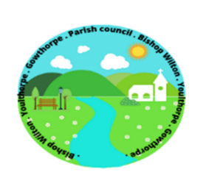

Parish Council of Bishop Wilton
You are hereby summoned to the Annual Meeting of Bishop Wilton Parish Council, to be held on
Monday 23rd May 2022 at 7.00pm in Bishop Wilton Village Hall.
If you are unable attend, please forward your apologies.
THIS IS AN OPEN MEETING AND MEMBERS OF THE PRESS AND PUBLIC ARE WELCOME TO ATTEND.
The items to be discussed and agreed are detailed below.
Parish Council Agenda items
- To receive Apologies.
- To receive nominations and agree election of Chair
- To receive Chair’s declaration of acceptance of office
- To receive nominations and agree election of a vice chair
- To receive Chair’s report for 2021/2022
- Approval and review of delegation of sub committees and appointment of officers – Personnel, Playground, Flyers and advertising, Gritting
- To agree councillors areas of responsibility and representation – School; Village Hall; Planning; Highways, Notice Boards,

- To elect 2 councillors to represent this Council at ERNLLCA district committee meetings
- To review year inventory of Land and Assets
- To review and approve insurance cover
- To review and approve governing documents
    - Code of Conduct
    - Publication Scheme
    - Complaints Procedure and Guidance
    - Small Grant Application and Guidance

Signed

Sandra Morrison
Parish Clerk

